**BEng/ BEng (Hons) Software Engineering**

**Module** – 4COSC006C - Software Development I

**Lecturer** - Mr. Mithshan jalangan

**Assessment type** –

**Assessment topic –** Creating Flow Charts

**Student Name –** S.S.U. Sachintha Chamod

**Student ID –** 20221948

**Question 1 (Easy):**

Problem: Write pseudocode and create a flowchart for a program that takes two numbers as input and displays their sum.

**Pseudocode**

BEGIN

#Getting input

Number1 = INPUT (“Enter the first number”)

Number2 = INPUT (“Enter the second number”)

#Calculate the sum of the two numbers

Sum = Number1 + Number2

#Output

Display (“Sum id: “+ Sum)

END

**Question 2 (Intermediate):**

Problem: Write pseudocode and create a flowchart for a program that finds and displays the largest number from a list of 10 numbers.

**Pseudocode**

BEGIN

#Getting variables

Largest number = 0

#Create the loop to input and compare all 10 numbers

FOR a FROM 1 TO 10

INPUT “Enter a number” + a + “:”

IF number > Largest number

Largest number = number

END IF

END FOR

#Get the output as largest number

OUTPUT “The largest number is : “ Largest number

END

**Question 3 (Moderate):**

Problem: Write pseudocode and create a flowchart for a program that checks if a given number is prime or not and displays the result.

**Pseudocode**

BEGIN

#Getting inputs

Number = INPUT (“Enter the number :”)

Is_Prime _number = TRUE

#Creat the loop to check the number divisibility

Divisor = 2

WHILE Divisor < Number

IF Number MOD Divisor + 0

Is_Prime_number = FALSE

EXSIT WHILE

END IF

Divisor = Divisor + 1

END WHILE

#Get the outputs as prime number or not the prime number

IF Is_Prime_number

PUTPUT Number “is prime number”

ELSE

OUTPUT Number “is no a prime number”

END IF

END

**Question 4 (Challenging):**

Problem: Write pseudocode and create a flowchart for a program that calculates the factorial of a number using a recursive function.

**Pseudocode**

BEGIN

#Getting inputs

Number = “Enter a number : “

#Chethe number is negative or positive

IF Number < 0

OUTPUT “Negative numbers can not be a factorial number.”

ELSE

#Add a function to calculate the factorial values and expand the number

Factorial = CalculateFactorial(Number)

#Show the output

OUTPUT “The factorial of the” Number “is” Factorial

END IF

END

**Question 5 (Easy):**

Problem: Write pseudocode and create a flowchart for a program that calculates and displays the factorial of a given number using a loop.

**Pseudocode**

BEGIN

#Getting inputs

Number = INPUT (“Enter a number”)

#Get the factorial to number 1

Factorial = 1

#Creeate a loop to calculate the factorial values

A = 1

WHILE A <= Number

Factorial = Factorial *1

A = a + 1

END WHILE

#Showing outputs

DISPLAY (“The factorial is: “ + Factorial)

END

**Question 6 (Intermediate):**

Problem: Write pseudocode and create a flowchart for a program that simulates a simple bank account system. The program should allow users to deposit, withdraw, and check their balance.

**Pseudocode**

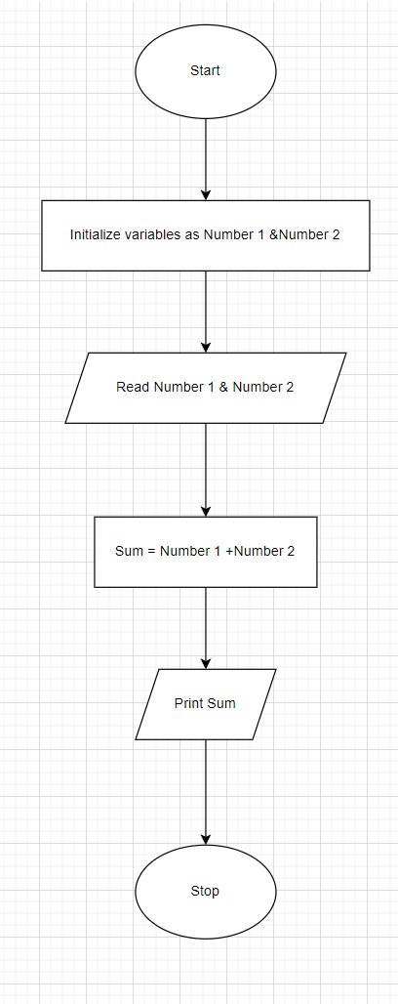Q 1,

Q 2,

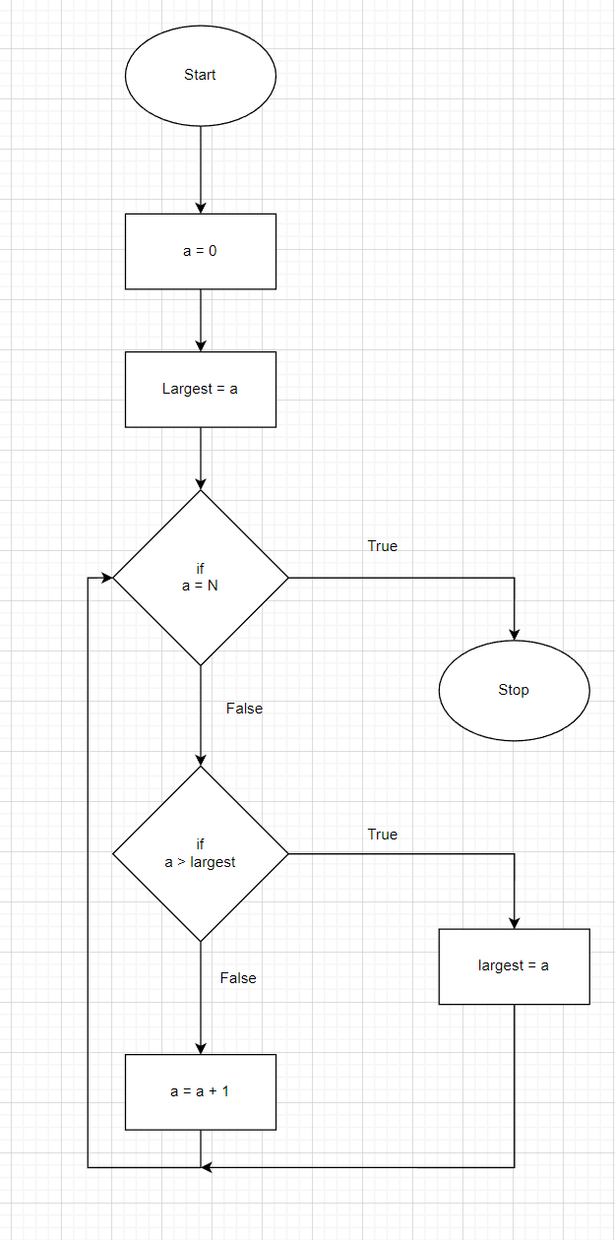

Q 3,

Q 4,

